CHM 1321 - Problem set 9

In this Problem set:
- Drawing and naming aromatic compounds
- Drawing resonance structures involving aromatic compounds
- Electrophilic aromatic substitution
- Manipulation of products of aromatic substitution
- Acidity/basicity is affected by aromaticity and substituents on aromatic rings
- Synthesis of benzene derivatives

Note: you should be able to draw the mechanism of each electrophilic aromatic substitution rxn in this assignment and clearly justify the formation of the major product(s) if applicable.

- Identify the aromatic, non-aromatic and anti-aromatic ring(s), if any, in the following molecules. Clearly explain each decision using the criteria given in class.

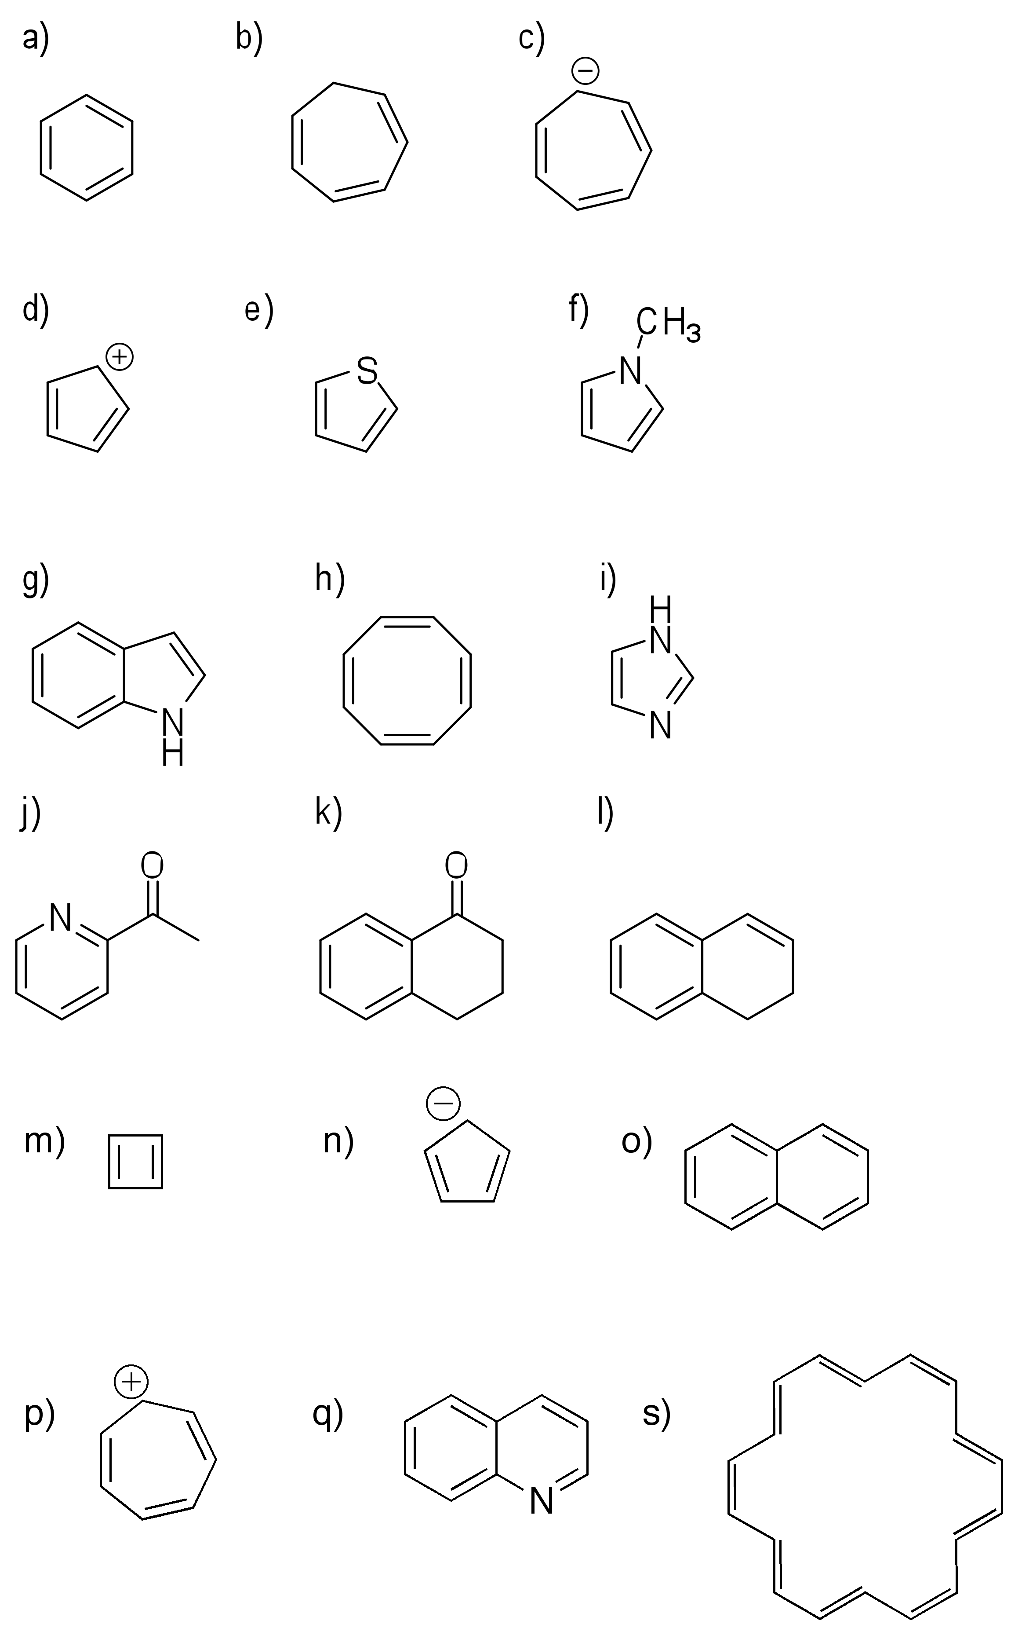

- Draw the structure of the following compounds:
a) m-dibromobenzene; b) 3-nitrotoluene; c) 2,6-dimethylphenol; d) 3,3-dichlorocyclopentene; e) o-hydroxybenzoic acid; f) benzenesulfonic acid; g) 2,5-dichloroaniline

- Name each of the following compounds using either an acceptable trivial name of the IUPAC nomenclature:

- Which of the following carbocations in each pair is most stable? Part of your answer should include showing the relevant resonance structures.

- Show how you would synthesize each of the following monosubsituted benzenes:
- Nitrobenzene
- Chlorobenzene
- Methylbenzene (toluene)
- Isopropylbenzene (2 ways)
- Acetylbenzene (acetophenone)

- Give the product expected or reagents required for each of the following reactions. Clearly justify the formation of the major product.

- Give the major product(s) that would be obtained when each of the following compounds is subjected to Br₂ and FeBr₃:
- Ethylbenzene
- Anisole
- Fluorobenzene
- Benzoic acid
- Nitrobenzene

- When benzene is reacted with 1-chloropropane and aluminum trichloride, a mixture of n-propylbenzene and isopropylbenzene is obtained. Explain by drawing the mechanism for the reaction.

- Draw a mechanism for the following transformation:

- What is the monobromination product expected from the reaction of the following molecules with Br₂ and FeBr₃?

- Explain the regioselectivity of following transformation by drawing the mechanism for the formation of the indicated product.

- Once substituted benzenes have been synthesized (by electrophilic aromatic substitution reactions or other methods), they can be modified to generate new products. Identify either the required reagents or the expected products in the following examples. Note: you are not responsible for part e.

- Which of the following aromatics would react most rapidly and which would react most slowly with Br₂/FeBr₃? Justify your answer and predict the structure of the major product.

- Consider the reaction of nitrobenzene with Br₂/FeBr₃. Why is the meta product the major product of this reaction?

- Aniline is much less basic than dimethylamine. Why?

- Which of the following phenols is most acidic? Why?

- Why are two of the following ions aromatic and one is not?

