CHM 2120
Problem set 2 - ANSWERS

- Use arrow notation to show the mechanisms of the following reactions. Use your mechanism to predict the product of the reaction. Identify the nucleophile, its nucleophilic atom, the α carbon of the electrophile and the leaving group.
Note: You can write the salt in the product either as NaCl (for example) or Na⁺, Cl⁻
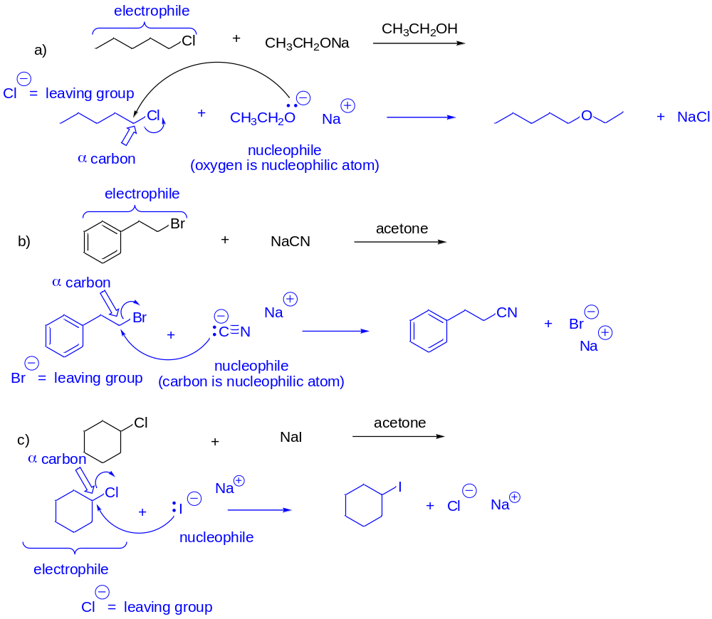
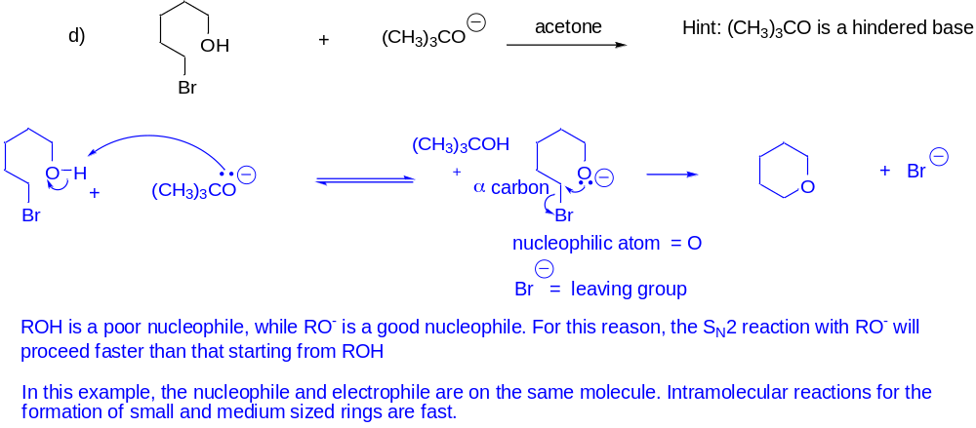
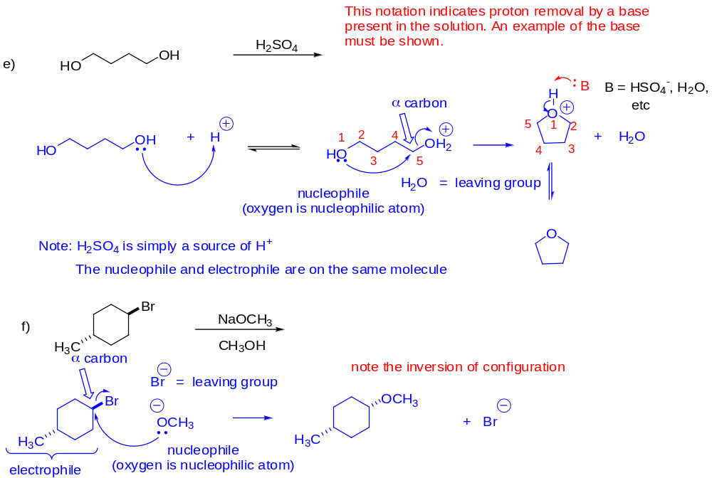For part f, E2 would be the major product.
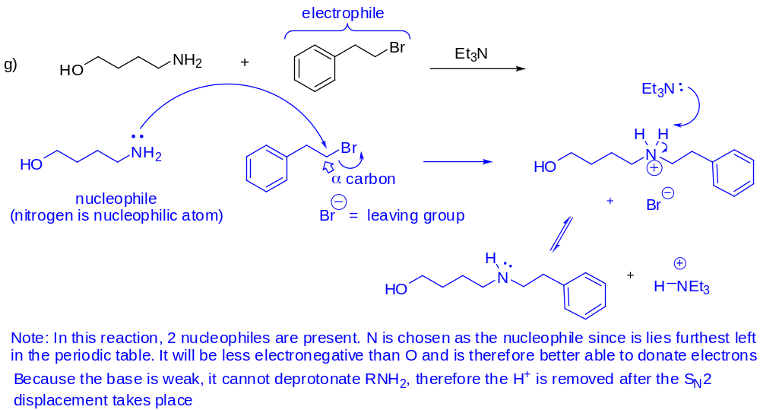

- A solution of 0.25 M cyclohexylbromide and 0.36 M CH₃NH₂ is created. Measurements show that the reaction produces 3.6 X 10⁻⁷ mol L⁻¹ of product each second.
- Calculate the rate constant for the reaction.
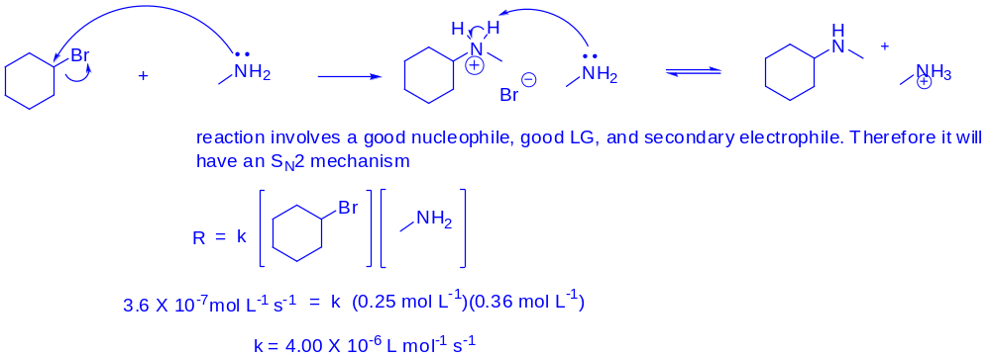

- If the concentration of CH₃NH₂ is changed to 0.15 M, what is the initial rate of the reaction?
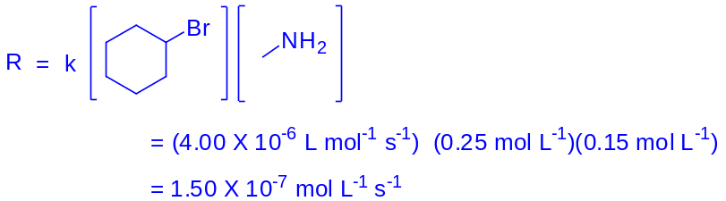

- Predict the relative rate (faster or slower) of the reaction if CH₃CH₂CH₂OH is used in place of CH₃NH₂ and justify your choice.
The reaction will be slower. Oxygen is more electronegative than nitrogen and is therefore less able to donate electrons. The oxygen-based nucleophile is therefore not as good as the nitrogen-based one and the reaction will therefore be slower.

- What could be done to the electrophile to increase the rate of the reaction? Briefly explain your reasoning.
Change the leaving group to a better one such as iodide. A better leaving group will stabilize the partial negative charge that is on the leaving group in the transition state. The reaction involving iodide will therefore be faster than that involving bromide.

- Could cyclohexanol be used to produce the same product? Why or why not? If not, how could this reaction be altered to make it work?
The reaction will not work simply by mixing alcohol and amine. Cyclohexanol has a poor leaving group (OH) and so the reaction will not proceed.
You cannot use acid to convert the OH to an OH₂⁺ because CH₃NH₂ is a stronger base than ROH and with therefore get protonated first. Protonating CH₃NH₂ makes it a bad nucleophile (CH₃NH₃⁺), and so a nucleophilic displacement reaction will not happen.
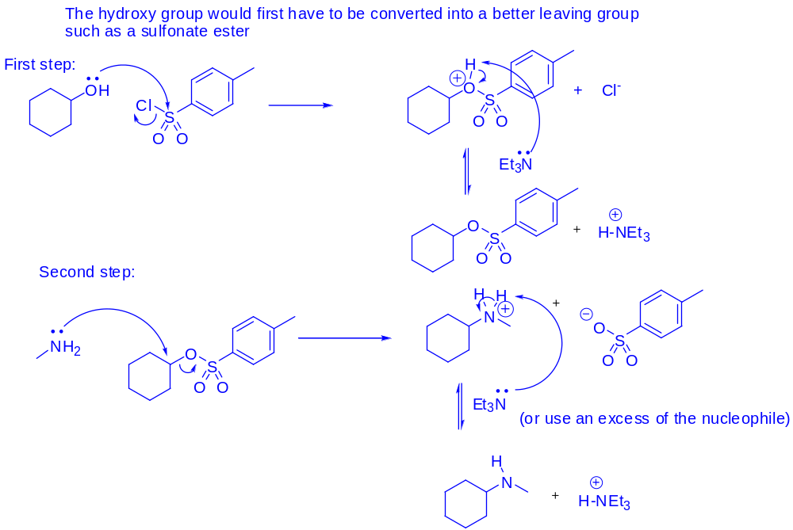
- Predict the effect on the reaction rate if (CH₃)₃CONa (a strong base) is added to a mixture of CH₃CH₂I and CH₃CH₂SH. Write an equation to show what is happening and provide a brief explanation of the effect.
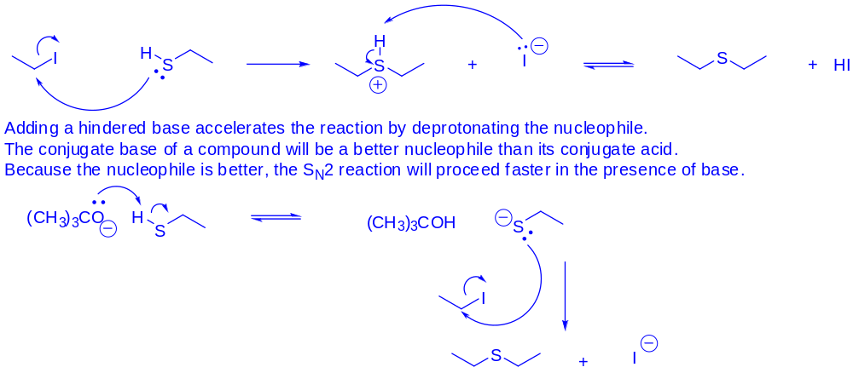
- Write a mechanism for each of the following reactions. Use your mechanism to predict the products of the reaction.
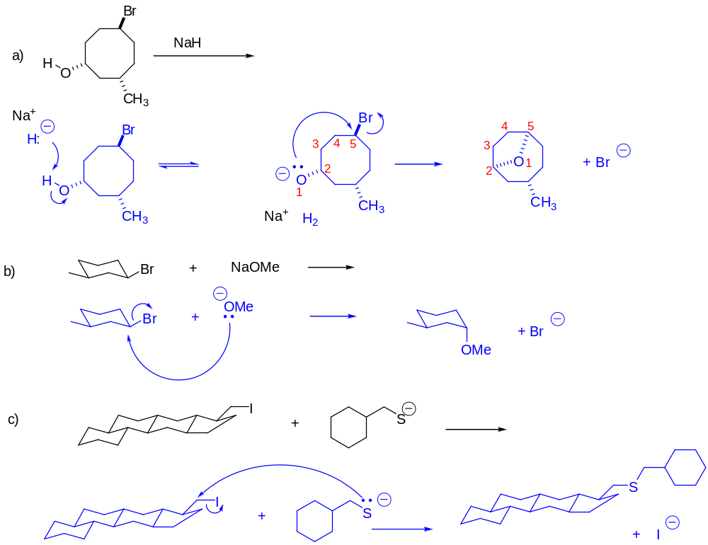
For part b, E2 would be the major mechanism, leading to alkene products.
- Predict the products of the following reactions. If no reaction is possible, write NR in place of the products. Write a mechanism for each transformation. Note: for parts g and i, the E1 products will also form

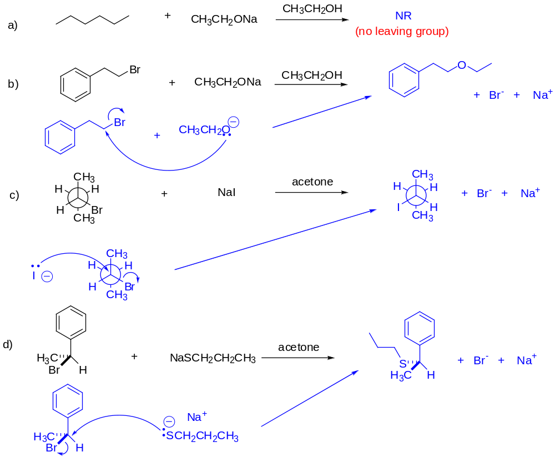
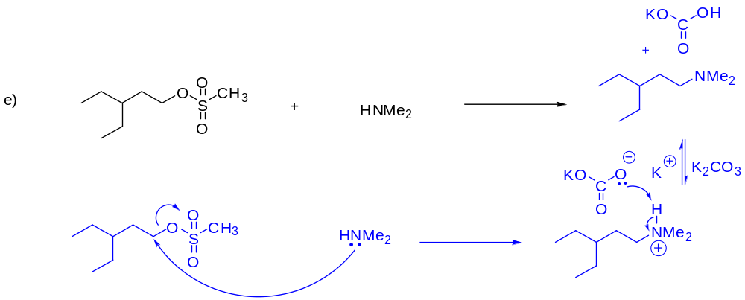
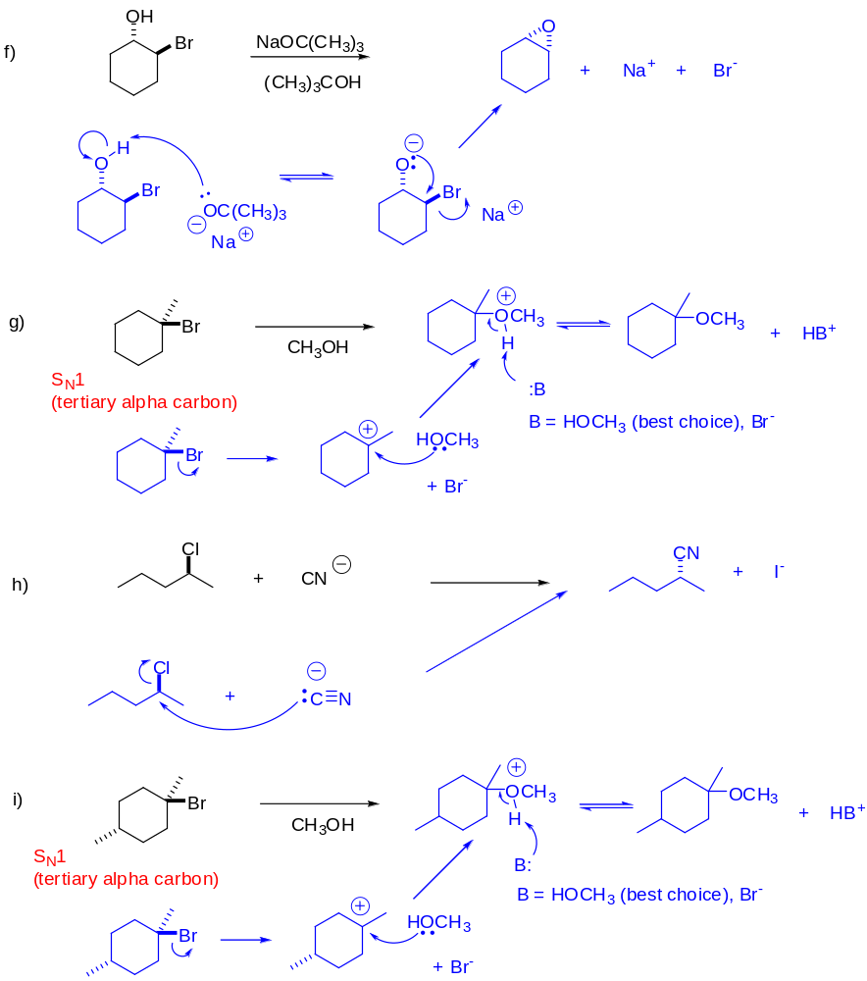

- Rank the following pairs of compounds in order of increasing S_{N}2 reactivity and explain your choices.
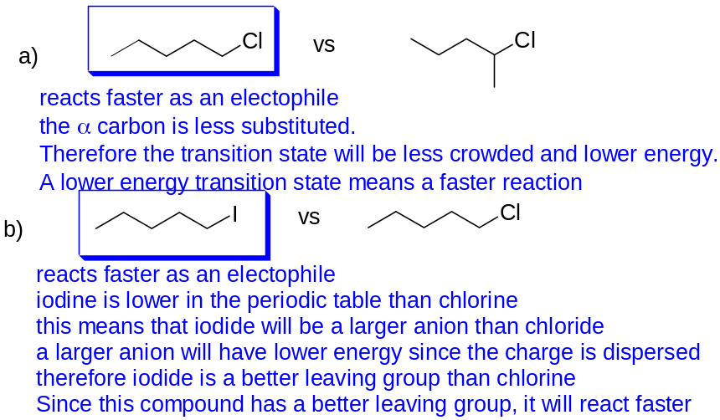
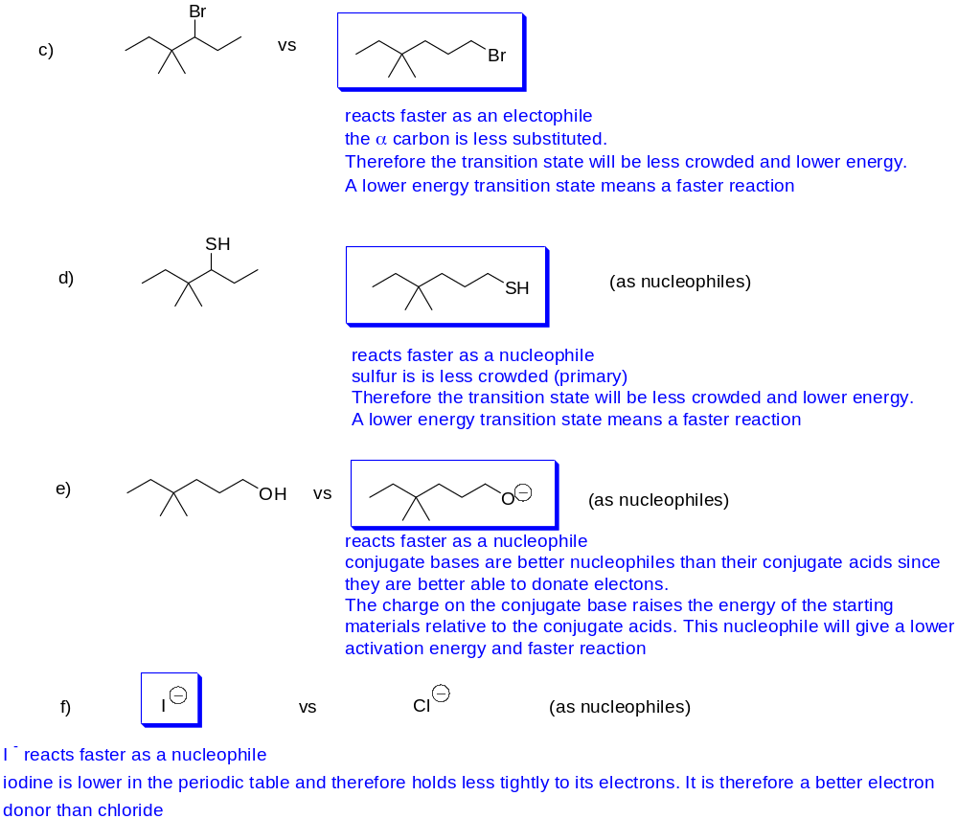
- During the following S_{N}2 reaction, it was noted that the product contained two enantiomers (was not enantiomerically pure, as expected), even though the starting material contained a single enantiomer (was enantiomerically pure).
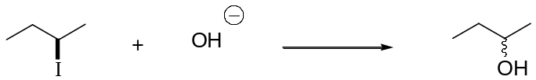
- What is the mechanism for the anticipated reaction?
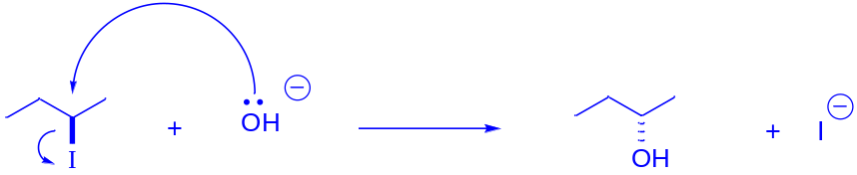
- Write a mechanism to explain the result observed.
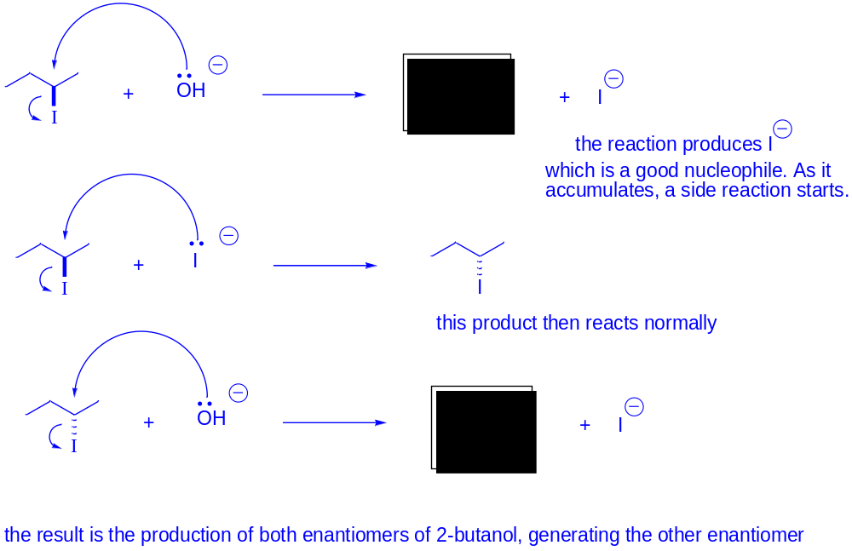

- For the following, predict which set of reaction conditions will give the fastest reaction. Justify your choice.
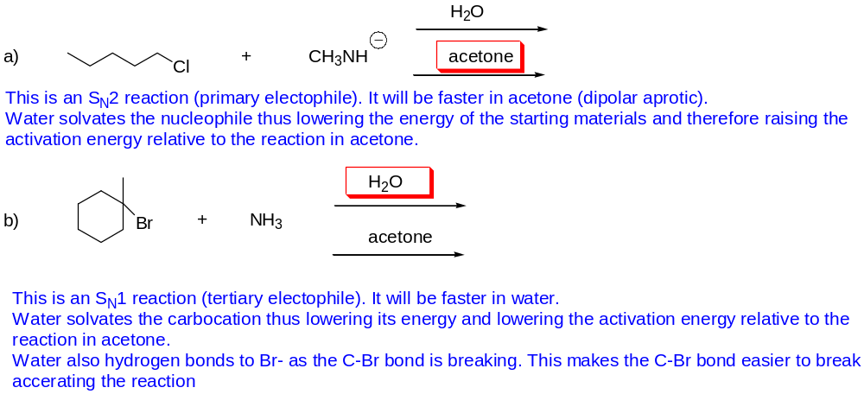
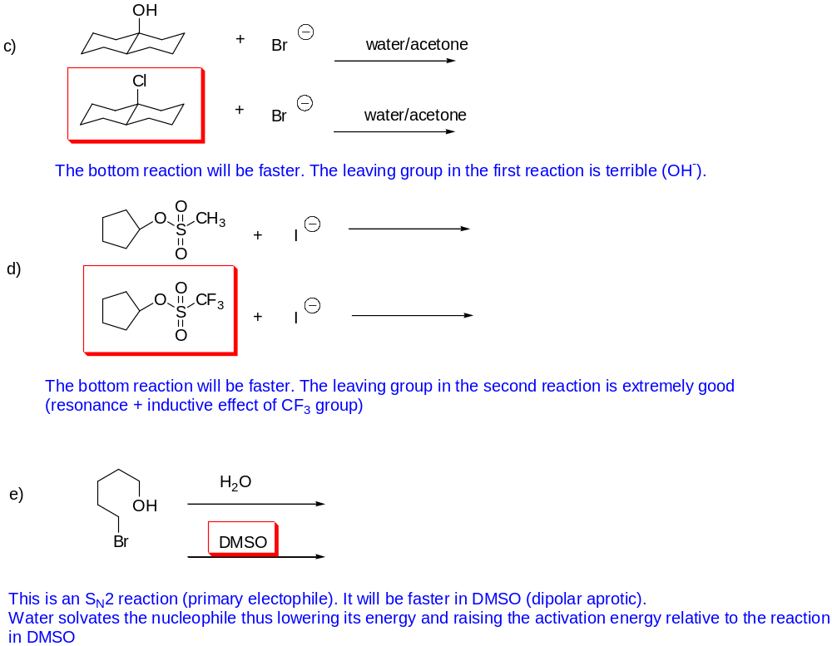
- Show how each of the following transformations could be achieved (write the reagents, and specify if the reagents are used in different steps or in the same step). Give a mechanism for each step. You may have to use more than one reaction to do some of these.
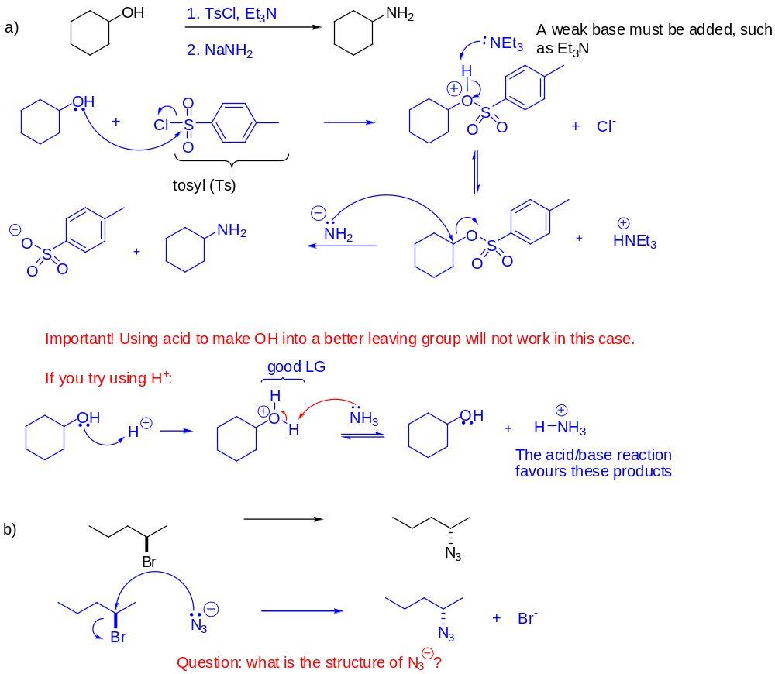

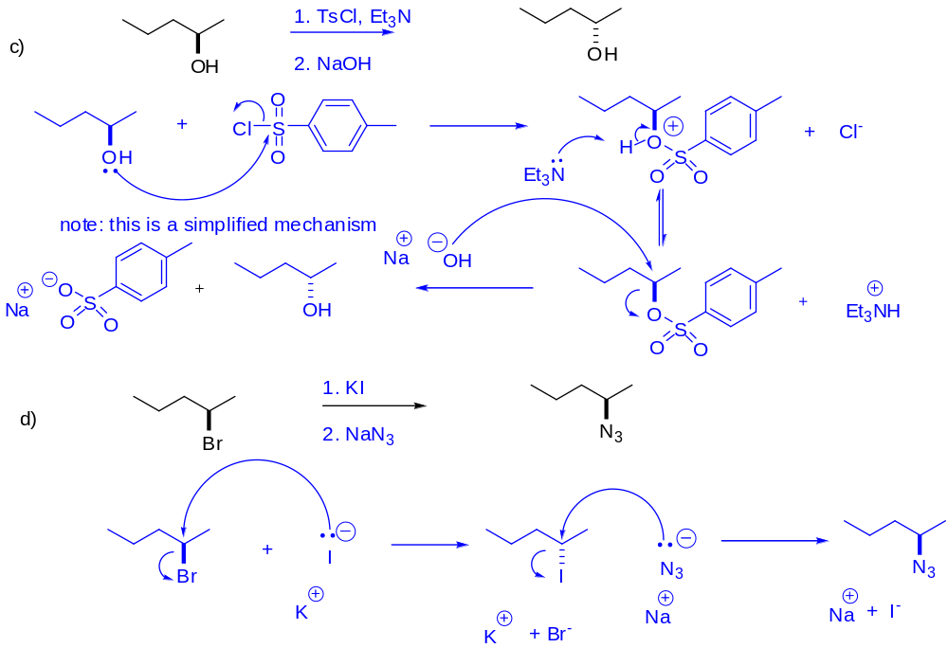
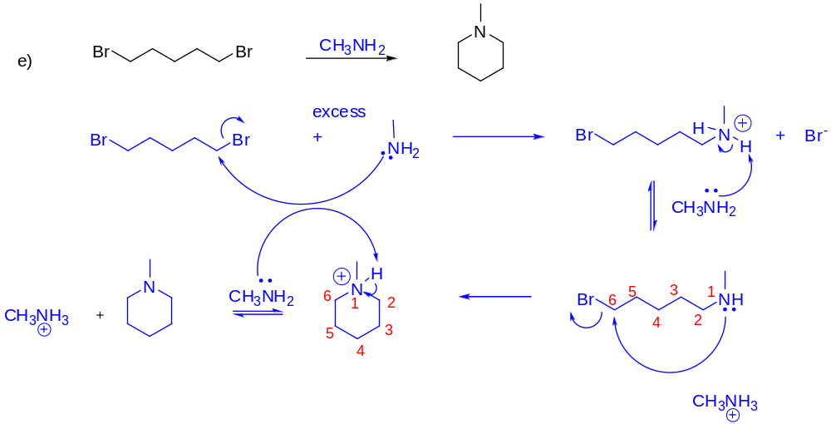
- 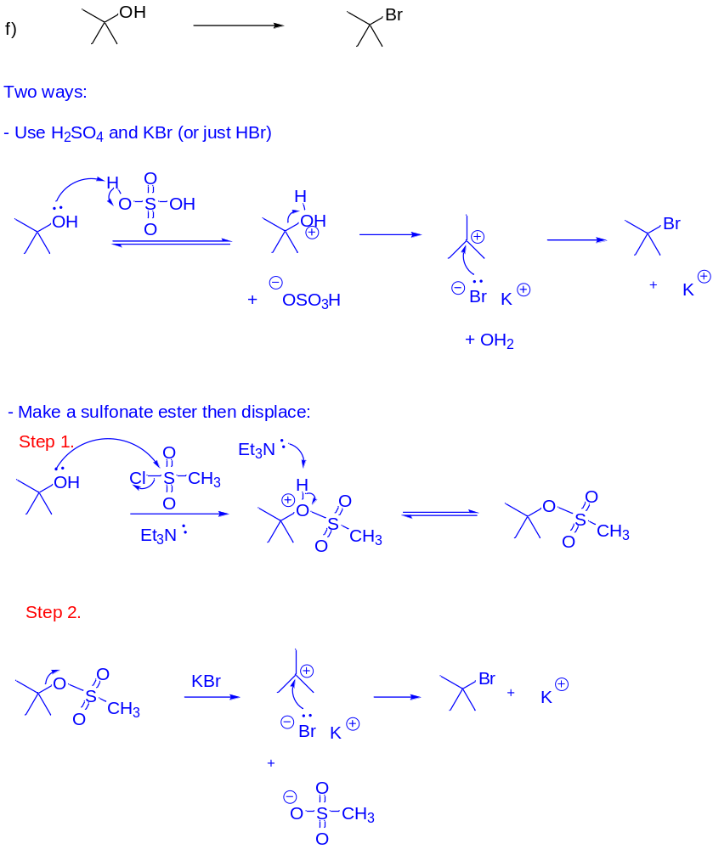
10. Challenge!
  - Give a mechanism for the following reaction, a key step in the synthesis of Crixivan, an HIV drug.
  - Many atoms in the nucleophile could be the nucleophilic atom (have lone pairs of electrons to donate). Why did the reaction only proceed as indicated? (hint: to answer this question, you have to analyze each potential nucleophilic atom and explain why it didn’t react).

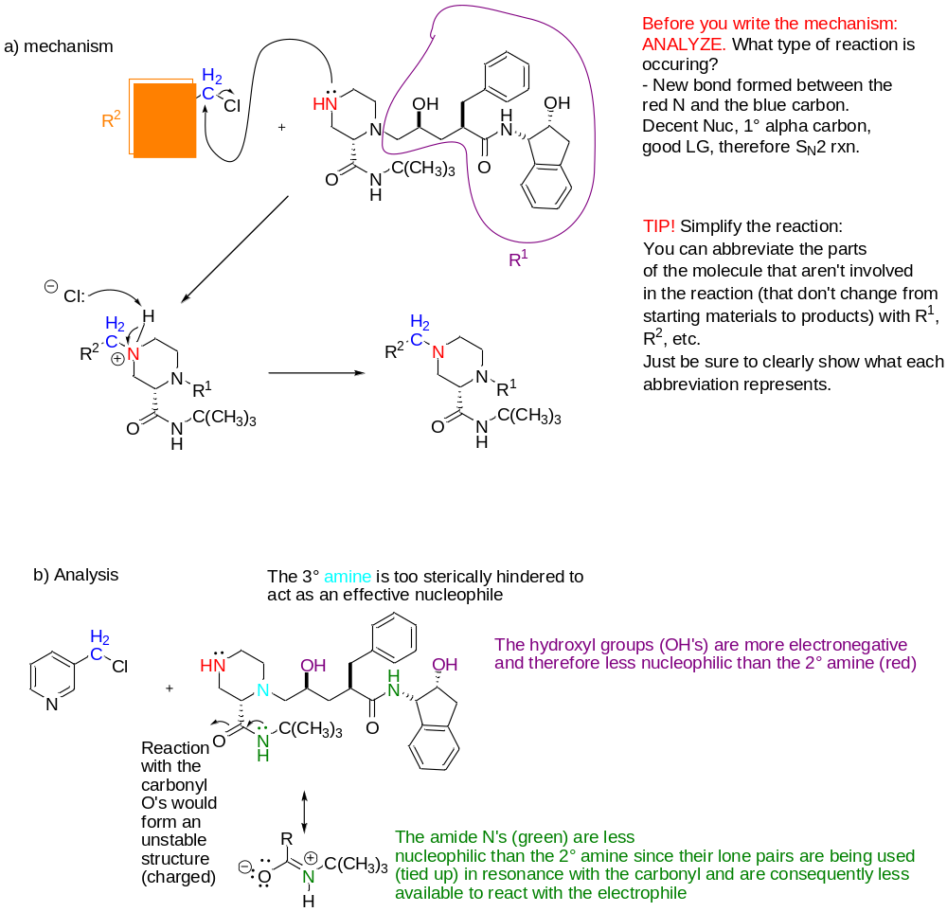

- State with reasons whether these reactions will be either S_{N}1 or S_{N}2. NOTE: on an exam, be sure to draw out all steps explicitly (e.g., proton transfers) and draw lone pairs on heteroatoms at the start of curved arrows (as applicable).

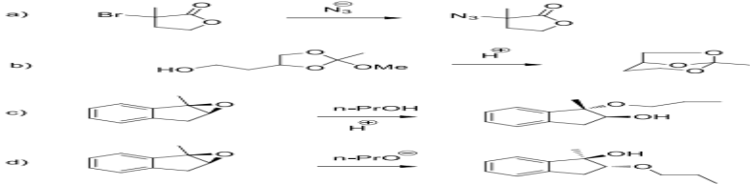S_{N}1

S_{N}1-like (to be covered in detail in the next module)

S_{N}2

S_{N}2

- Account for the contrasting results in these two reactions.

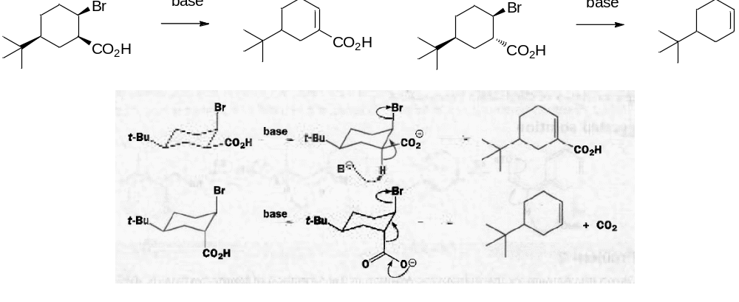

- Only one of the diastereomic bromides shown here eliminates to give alkene A. Why? Neither bromide gives alkene B. Why not?

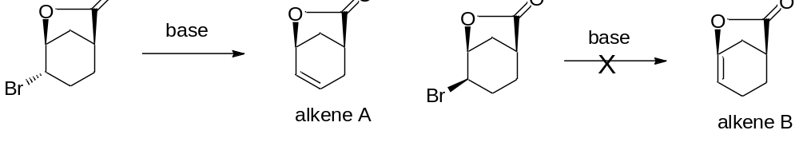
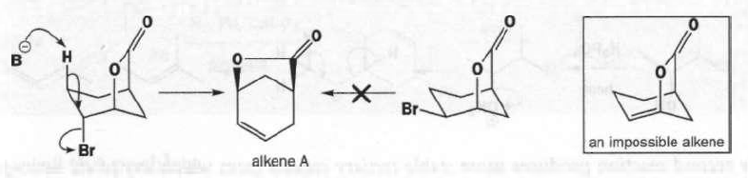

- Suggest mechanisms for these two eliminations. Why does the first one give a mixture and the second a single product? (Note: in part b, a short form for the mechanism is shown—be sure that you show the full mechanism (e.g., the protonation step with the acid and show a base for the deprotonation).

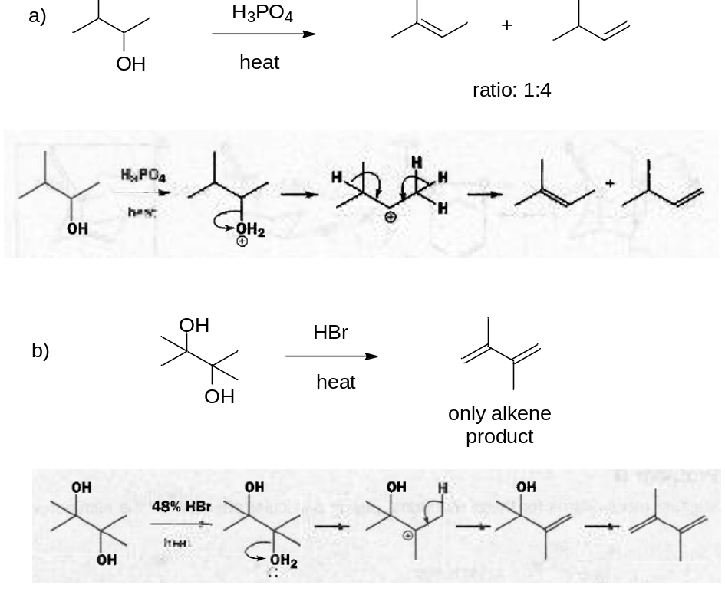
- Suggest a mechanism. Be sure to show all proton transfer steps separately on an exam.

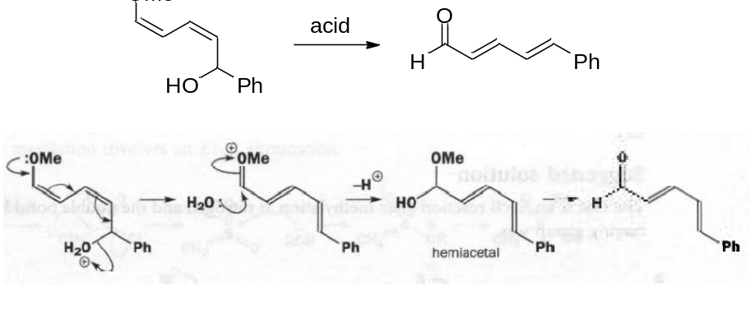

- Suggest a mechanism. Be sure to show all proton transfer steps separately on an exam.



