**CHM 2120 – Problem set 6**

**In this problem set:**

* Enols & enolates
* Aldol reaction
* Synthesis

1. Give the IUPAC names or accepted trivial names for the following molecules:



1. Draw structures for
   1. 2-methylbutyl pentanoate
   2. *N*-benzyl-2-bromobutanamide
   3. 3-nitrobenzoyl chloride
   4. *p*-nitrophenyl acetate
   5. *meta*-dinitrobenzene
   6. 2-chlorobutanoyl chloride
   7. Triphenylphosphine
   8. Triphenylphosphine oxide
   9. Diazomethane, CH2N2 (the two most important resonance structures)
2. Draw the mechanism for the tautomerization of 1-phenyl-1-butanone (also known as butyrophenone and phenyl propyl ketone) by
   1. acid catalysis
   2. base catalysis



* 1. What is the key tautomer of the molecule shown below?
  2. Which would be the major tautomer at equilibrium? Why?
  3. How could you prove the structure of the major tautomer by IR?



* 1. Draw a mechanism for the generation of the compounds shown below.
  2. Describe how the 1H NMR of the starting material would differ from the 1H NMR of the two products.

**Note:** H = 1H 🡪 detected by 1H NMR (peaks are seen)

D = 2H 🡪 not detected by 1H NMR (no peaks)



1. A solution of dimedone (5,5-dimethylcyclohexane-1,3-dione) in chloroform contains 33% of an enol tautomer. Draw this tautomer and explain why it is found in much higher proportion than most enols.
2. A tautomer of vitamin C shown below is not the most stable one.
   1. Draw the more stable tautomer
   2. Why is vitamin C, also called ascorbic **acid**, so acidic? Note: the 1st pKa of vitamin C is 4.6 (similar to that of a carboxylic acid) whereas typical alcohols have pKa’s in the range of 16-18.



1. The following IR spectrum of a sample of methyl acetoacetate shows the presence of an OH group. The 1H NMR of the sample also shows three peaks at 5.00, 3.72, and 1.96 ppm in addition to the expected peaks at 3.75, 3.47, and 2.27 ppm. What do these additional peaks represent?

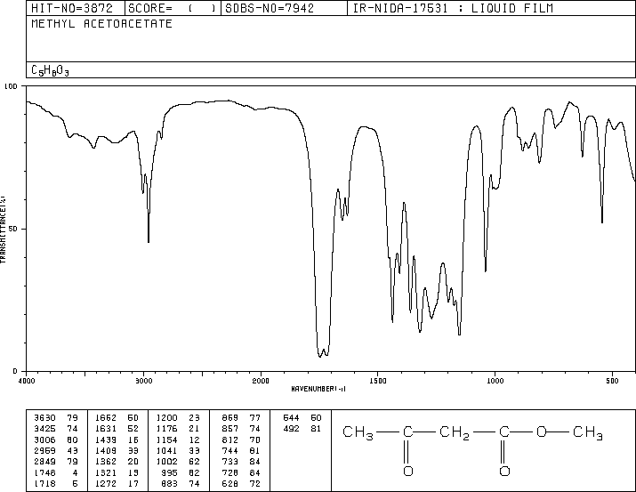

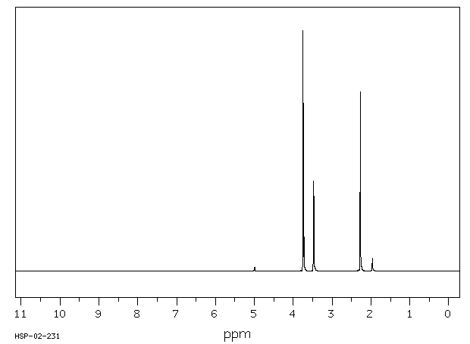



9.

* 1. Give the product of the following reaction
  2. Draw the resonance forms of the product
  3. Identify the hybridization of each atom in the starting material and in the product and explain any differences.



1. Provide a mechanism to explain the following interconversions.

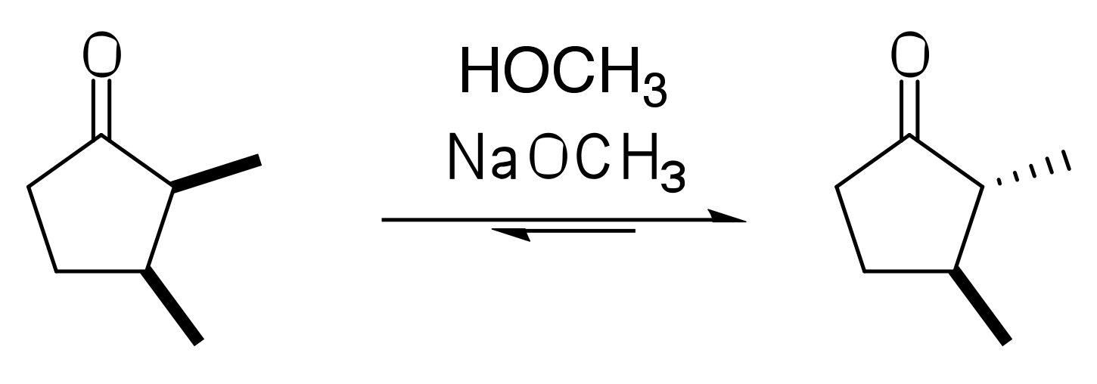





1. Which of the protons identified in the following pairs is most acidic? Why?









1. Predict the products of self-condensation followed by dehydration:





1. Give the product of the following reactions.



1. Predict the crossed aldol condensation products:







1. Give the intermediate obtained after each step and the final product of each sequence.













1. Predict the major product expected from each of the following reactions and include a mechanism for each step.

























1. Suggest a synthesis of the following molecules. An analysis/brainstorming and retrosynthetic analysis are required.





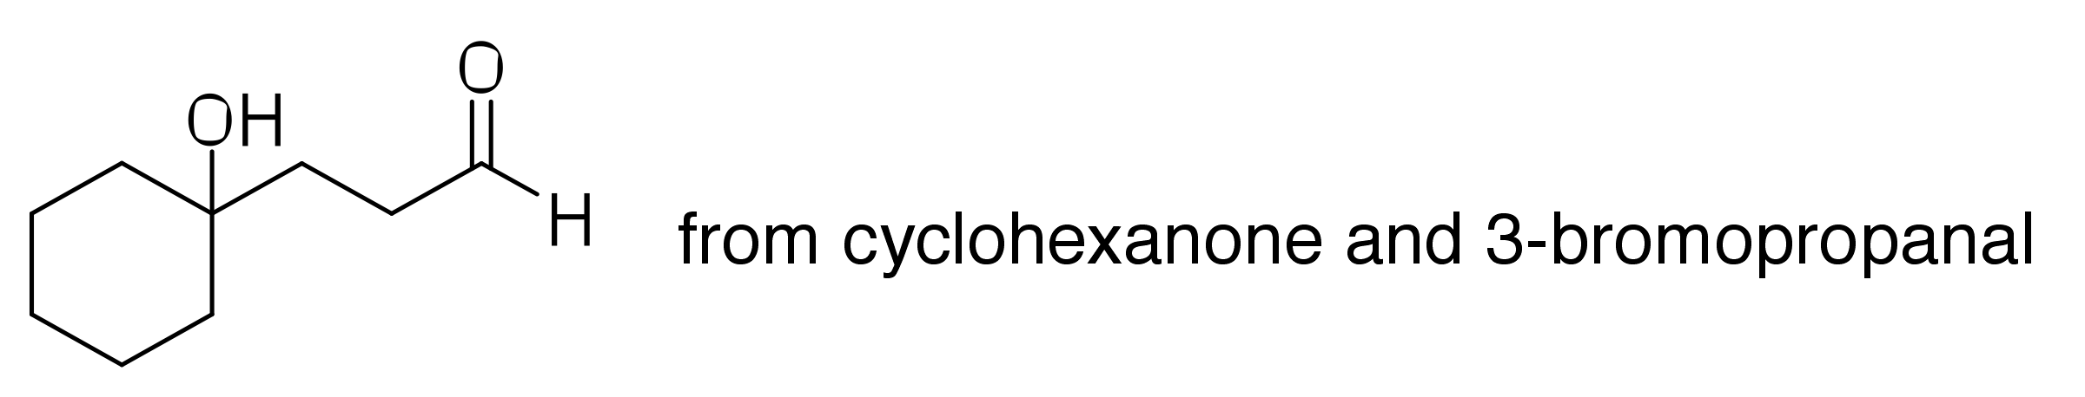



















1. The aldol reaction can be accomplished using an acid catalyst. Give a mechanism and product for the following transformation:



1. Propose a synthesis of the following compounds. A retrosynthetic analysis must also be included.























1. )













1. Provide a mechanism for the following transformations:











1. (**Question 5 continues**)





1. Propose a synthesis of the following compounds. A retrosynthetic analysis must be provided.

















1. Provide a mechanism and product for the following reactions.









1. The following sequence brings together reactions from different parts of the course. Provide a mechanism for each step and give the structure of the final product.



1. Suggest mechanisms for these reactions.

