**CHM 1321 – Problem set 7 - ANSWERS**

**In this set:**

* Nucleophilic addition to carbonyls and other pi bond electrophiles
* Acid/base chemistry

1. Name the following compounds



1. Draw the structure corresponding to the following names:



1. Can Grignard reactions be conducted in protic solvents? Explain.

NO. The Grignard reagent, such as methylmagnesium bromide would be destroyed through an acid/base reaction with the solvent (such as methanol). See class notes for the mechanism.

1. How could you synthesize the following deuterium-labeled compound from bromobenzene? Note: D2O is readily available. D = 2H, an isotope of 1H



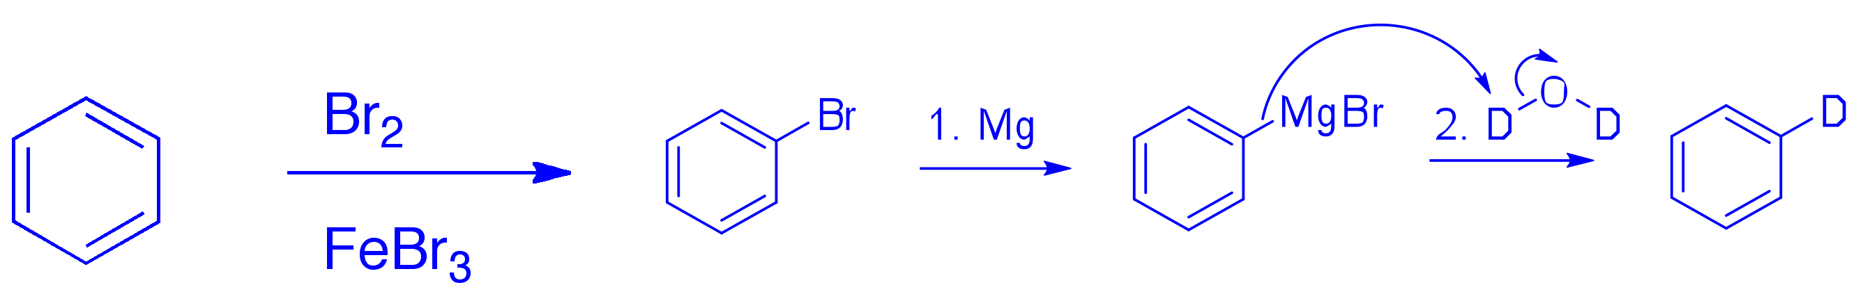

1. Give the product of each of the following reactions:



1. Provide a mechanism for the first step in each of the following reactions:



1. Draw one set of starting materials (electrophile and nucleophile) for each of the following products (assume aqueous workshop):



Question 7, continued:

1. See mechanisms for a-b, below.



Question 8, cont. Mechanisms

