**CHM 1321 - Problem set 9**

**ANSWERS**

**In this Problem set:**

* Drawing and naming aromatic compounds
* Drawing resonance structures involving aromatic compounds
* Distinguishing aromatic from antiaromatic compounds
* Electrophilic aromatic substitution
* Manipulation of products of aromatic substitution
* Acidity/basicity is affected by aromaticity and substituents on aromatic rings
* Synthesis of benzene derivatives

**Note**: you should be able to draw the mechanism of each electrophilic aromatic substitution rxn in this assignment and clearly justify the formation of the major product(s) if applicable.

1. Identify the aromatic, non-aromatic and anti-aromatic ring(s), if any, in the following molecules. Clearly explain each decision using the criteria given in class.

|  |  |  |  |  |  |  |
| --- | --- | --- | --- | --- | --- | --- |
| **Part** | **Compound** | **Ring is  planar?** | **All atoms  sp2-hybridized?** | **4n + 2   electrons?**  **(n=0,1,2…)** | **Aromatic?**  **(conclusion)** | **Comments** |
| a |  | Yes | Yes | 6 (n = 1)  Yes | YES |  |
| b |  | No | No (CH2 is sp3) | Yes | NO – non-aromatic |  |
| c |  | Yes | Yes | 8 (n = 1.5)  No | NO- antiaromatic | Satisfies 4n rule |
| d |  | Yes | Yes | 4 (n = 0.5)  No | NO – antiaromatic | Satisfies 4n rule |
| e |  | Yes | Yes | 6 total (4 from  bonds, 2 from lone pair)  Yes | YES | Red e-‘s are in a p orbital; blue e-‘s are in an sp2 orbital |
|  |  |  |  |  |  |  |
| **Part** | **Compound** | **Ring is  planar?** | **All atoms  sp2-hybridized?** | **4n + 2   electrons?**  **(n=0,1,2…)** | **Aromatic?**  **(conclusion)** | **Comments** |
| f |  | Yes | Yes | 6 (n = 1)  Yes | YES | Red e-‘s are in a p orbital; |
| g |  | Yes | Yes | 10 total (8 from  bonds, 2 from lone pair); n = 2  Yes | YES | Red e-‘s are in a p orbital; |
| h |  | No (see a model) | Yes | 8  e-‘s total  No | NO – antiaromatic | Satisfies 4n rule |
| i |  | Yes | Yes | 6 total (4 from  bonds, 2 from lone pair); n = 1  Yes | YES | Red e-‘s are in a p orbital; blue e-‘s are in an sp2 orbital |
| J |  | Yes | Yes | 6 total; n = 1  Yes | YES | The electrons from the carbonyl don’t count (they are outside the ring); the blue e-‘s are in an sp2 orbital |
| K |  | Yes | Yes | 6 total; n = 1  Yes | YES (the ring on the left); the ring on the right is non-aromatic | The electrons from the carbonyl don’t count (they are outside the ring); |
| L |  | Yes | Yes | 6 total; n = 1  Yes | YES (the ring on the left); the ring on the right is non-aromatic | The electrons from the double bond outside the phenyl ring don’t count |
| M |  | Yes | Yes | 4 total; Not aromatic | NO - Antiaromatic | Satisfies the 4n rule (n=1) |
| N |  | Yes | Yes | 6 total; n=1  Yes | Aromatic | The lone pair of electrons on the carbanion is in a p orbital |
| O |  | Yes | Yes | 10 total; n=2  Yes | Aromatic |  |
| P |  | Yes | Yes | 6 total; n=1  Yes | Aromatic | The carbocation is sp2 hybridized. The  electrons are delocalized through the empty p orbital on the carbocation |
| **Part** | **Compound** | **Ring is  planar?** | **All atoms  sp2-hybridized?** | **4n + 2   electrons?**  **(n=0,1,2…)** | **Aromatic?**  **(conclusion)** | **Comments** |
| Q |  | Yes | Yes | 10 total; n=2  Yes | Aromatic | The lone pair of electrons on the N is in an sp2-hybridized orbital—it is perpendicular to the  system and is not involved in resonance |
| R |  | Yes | Yes | 18 total; n=4  Yes | Aromatic |  |

1. Supply a clear structure of:



1. Name each of the following compounds using either an acceptable trivial name of the IUPAC nomenclature:

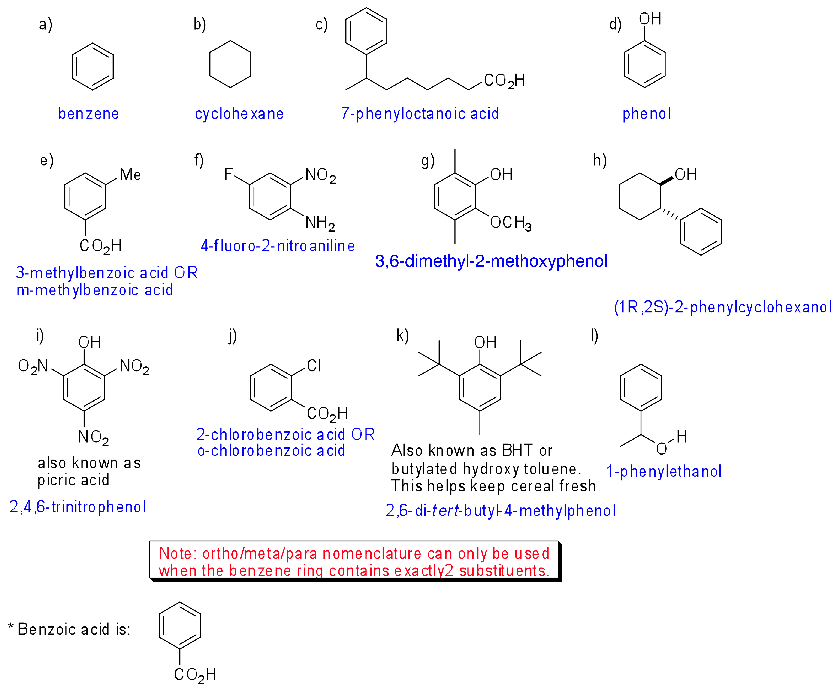

1. Which of the following carbocations in each pair is most stable? Part of your answer should include showing the relevant resonance structures.
   1. 









1. Show how you would synthesize each of the following monosubsituted benzenes:
   1. Nitrobenzene



* 1. Chlorobenzene



* 1. Methylbenzene (toluene)



* 1. Isopropylbenzene (2 ways)



* 1. Acetylbenzene (acetophenone)



1. Give the product expected or reagents required for each of the following reactions. Clearly justify the formation of the major product.

**Note: you could be asked on the test to support your answer with a mechanism and any relevant resonance structures as shown in class.**



1. Give the major product(s) that would be obtained when each of the following compounds is subjected to Br2 and FeBr3:



1. When benzene is reacted with 1-chloropropane and aluminum trichloride, a mixture of n-propylbenzene and isopropylbenzene is obtained. Explain by drawing the mechanism for the reaction.



1. Draw a mechanism for the following transformation:



1. What is the monobromination product expected from the reaction of the following molecules with Br2 and FeBr3?



1. Explain the regioselectivity of following transformation by drawing the mechanism for the formation of the indicated product.

**Note:** This question required that the regioselectivity (where the substituent is added) be explained, as well as the formation of the *tert*-butyl substituent via rearrangement.



1. Once substituted benzenes have been synthesized (by electrophilic aromatic substitution reactions or other methods), they can be modified to generate new products. Identify either the required reagents or the expected products in the following examples.



1. Which of the following aromatics would react most rapidly and which would react most slowly with Br2/FeBr3? Justify your answer and predict the structure of the major product.





1. Consider the reaction of nitrobenzene with Br2/FeBr3. Why is the meta product the major product of this reaction?



1. Aniline is much less basic than dimethylamine. Why?



1. Which of the following phenols is most acidic? Why?



1. Why are two of the following ions aromatic and one is not?

